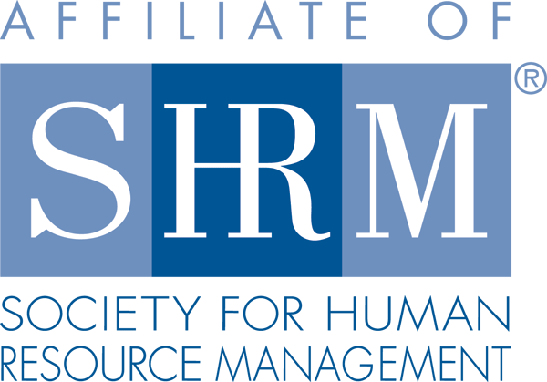
Mentor Program Application

Personal Information
 | Student ID #
Last |  |  |  |  | First |  |  |  |  | M.I. |  |  |  |  | First |  | M.I.
 |  | Email Address |  |  |  |  |  | Phone Number |  |  |  | Semester/Year

Educational Information

Student Status:
☐ | Freshman | ☐ | Sophomore | ☐ | Junior | ☐ | Senior | ☐ | Graduating Senior | ☐ | MBA

Enrollment Status:
☐ | Full Time | ☐ | Part-time | Expected Grad Date: _____________

HR Interest

Please check all that apply:
☐ | Compensation & Benefits | ☐ | HR Research/Analytics | ☐ | Employee & Labor Relations
☐ | Training & Development | ☐ | Employment Practices | ☐ | Workplace Health & Safety
☐ | Workplace Diversity | ☐ | Staffing & Recruiting | ☐ | HRIS
☐ | Unknown/Any of the above

Professional Experience & Program Interest

HR Work/Volunteer/Internship Experience:
Why do you want to participate in the Mentor Program and what do you hope to achieve?

Please email your completed applications to vpmentorship.shrmatsjsu@gmail.com .
Officer Use Only
Submission Method :
Date Received: Date Mentor Assigned:
Mentor’s Company Name:

